Backcasting methodology for national financial accounts


The background
The French national accounts are currently published from 1995 onwards, and follow harmonized rules at European level (according to the European System of Accounts 2010). In the past, there have been several methodological developments or changes in accounting recording principles, which mean that it is not always easy to present consistent statistics with constant methodologies over a long period. In particular, in September 2014, the new European standard, the "European System of National and Regional Accounts - ESA 2010" came into force for the calculation of national accounts and thus succeeded ESA 1995 as the reference methodology. While it has retained the general foundations and principles of its predecessor, ESA 2010 has introduced some changes to better match the changing way our economy operates.
This change of benchmark (as well as the previous ones) led to revisions that were often significant and linked, for example, to changes in accounting principles, reclassifications of entities or changes in financial operations or institutional sectors. These revisions cause breaks in the time series.
For example, while the accounts currently published ("2014 benchmark" in national accounts terminology) cover the period from 1995 to the present day, there are also older statistics ("2000 benchmark") which cover the period from 1977 to 2009, but which are not entirely consistent and comparable, as can be seen if only by comparing them over their common period between 1995 and 2009.

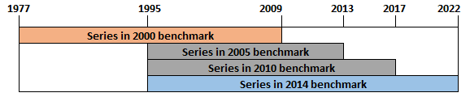
Figure 1: Time periods covered by the various national financial accounts benchmarks

The aim of the backcasting work was therefore to make the long-term time series homogeneous once again, in order to obtain statistical series from 1977 to the present day. The aim of this article is to detail the principles and methods used to carry out this backcasting. The financial accounts backcasted series over a long period, from 1977 to the present day, are available on the Banque de France's statistical portal.

- The methodological joint

The ESA 2010 has introduced a number of changes to the nomenclature of both institutional sectors and instruments. The format of the internal code has also been changed.

The annual series in 2000 benchmark are available on the Banque de France website. The 2876 series cover the period from December 1977 to December 2009. The detail is "all counterparty" (also referred to as total economy), meaning that for each instrument, we have the liabilities and assets of a sector (households, NFCs, etc.) but, unlike the 2014 benchmark, we do not have "who-to-whom" series (for example, bank loans to households).
The aim of backcasting is to 'link' these 2000 benchmark series to the 2014 benchmark series, which are the series currently published on all the usual statistical dissemination media (Webstat, Stat Info, data shared by international organisations, etc.).
Direct observations are generally not available for households, and for non-financial corporations they are usually late and not very detailed. As a result, the financial accounts for these two sectors are based mainly on information reported by the other sectors.

2.1. Transcoding
The first step was to carry out a translation between the old codification of the series and the one currently in use. Fortunately, as illustrated in the graph below, the process is injective in the sense that a new code can be assigned to any old series. The new dimensions present in the new code are not then fully used (they are used in the whom to whom series produced in the current benchmark). These whom to whom series will not be backcasted due to a lack of relevant data to do so (absence of data in the old benchmark and of robust data identified to make even good approximations).

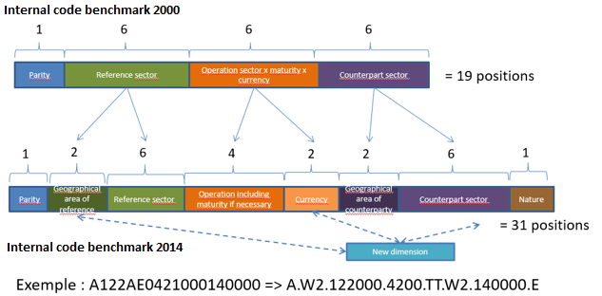

2.2. Changes in financial instruments and institutional sectors between ESA 1995 and ESA 2010
The following tables show the differences between financial instruments and institutional sectors in ESA 1995 and ESA 2010.
The main changes concern the breakdown into financial instruments. For the sake of simplicity, several instruments present in the ESA 1995 disappear and are grouped together in other instruments such as long-term interbank market securities, accrued interest on debt securities and some loan sub-breakdowns. On the other hand, the ESA 2010 introduces new instruments, such as the distinction between "unquoted shares" and "other equity", or the distinction between rights to life insurance technical reserves and rights to pension funds (made up of retirement savings pending the creation of an S129 pension fund sector in France for the next benchmark revision in 2024).
As far as institutional sectors are concerned, only one new sector, captive financial institutions and non-institutional lenders, appears in the ESA 2010.

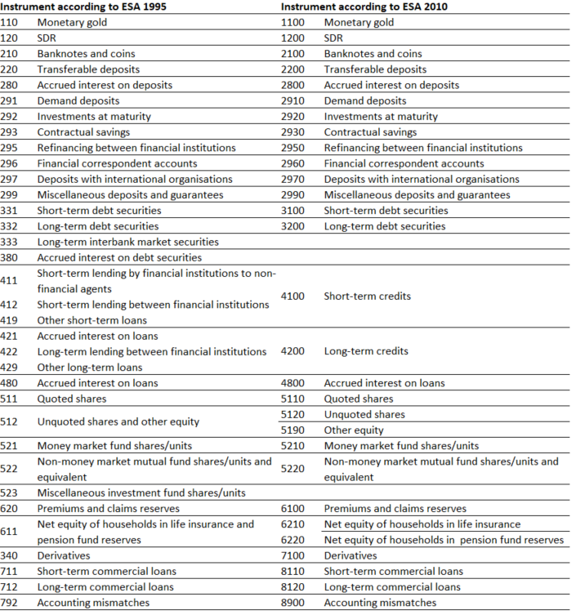

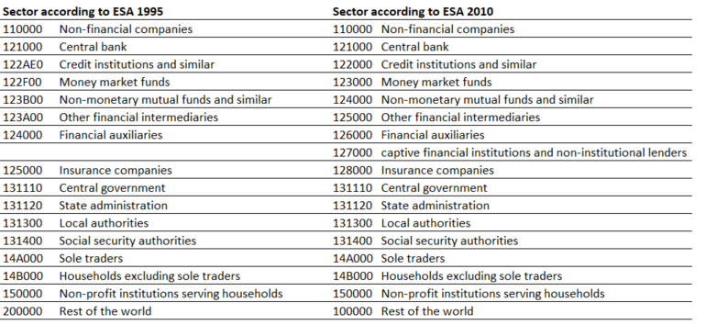

For all these changes, we identified which instruments or sectors were impacted (including, for example, which instruments the disappearing instruments were allocated to). We also had to determine the breakdown coefficients to be applied in the various cases (new series or series that are disappearing). Appendix 1 provides a detailed description of the instruments and sectors used, as well as explanations of the breakdown coefficients chosen.

3. The main backcasting algorithm

In view of the large number of series to be backcasted, we have set up a backcasting algorithm which will form the core of our methodology and which we will describe in detail here. Because of the difficulty of making choices adapted to every situations, we have also allowed ourselves a few manual adjustments, which we will detail at the end.

In national accounts, changes in outstanding amounts (stocks) between two periods are based on the following relationship:

$${Stock}_{q}={Stock}_{q-1}+F{low}_{q}+Revaluation_{q}+{Other changes in volume}_{q}$$

Flows correspond to transactions carried out over the period, revaluations to the impact of changes in market prices and other changes in volume to various effects such as reclassifications (of instruments or sectors, for example), the creation or disappearance of entities, methodological changes or the use of new sources that could not be backcasted.

It is natural to start backcasting stocks. In the preparation of financial accounts, most data sources are available in the form of stocks. Stock series are therefore generally robust (in both the old and the new benchmark), so it is preferable to backcast them first and then use them to backcast the other series. As we shall see, valuation effects are fairly easy to deduce and remain closely linked to levels of stocks. The question then arises whether to try to backcast flows (using a method more or less similar to that used for stocks) and deduce other changes in volume using the formula above, or conversely to backcast changes in volume and deduce flows. We have tested both approaches, each of which has its advantages and disadvantages. It turns out that if flows are backcasted, there will inevitably be differences in the consistency of the backcasting of stocks on the one hand and flows on the other. These differences will then create values for other changes in volume that are too noisy to be usable in practice and too different from what was observed for the old benchmark, even for instruments that were not impacted very much. We have therefore chosen to backcast the other changes in volume and deduce the flows from them, even though, as we shall see, backcating these changes in volume proves to be tricky.

In what follows, we will describe in turn the choices made for backcasting stocks, revaluation effects and changes in volume. As indicated, flows will be deduced from knowledge of the three preceding quantities.

3.1. Backcasting of stocks

For stocks (noted S hereafter), the choice made was to retain the current 2014 benchmark from 1995 to the present day, then to calculate the annual growth rates observed in 2000 benchmark over the period from 1977 to 1995 and to apply these growth rates backwards to the stocks data previously obtained in order to go back in time in the new benchmark.
$$S_{N-1, benchmark 2014}=S_{N, benchmark2014}*\frac{S_{N-1, benchmark2000}}{S_{N, benchmark2000}}$$
This makes it possible to align the two benchmarks perfectly for the 1995 transition year and to maintain the dynamics as observed in benchmark 2000.
When the series in benchmark 2000 and benchmark 2014 are close, the approach raises few questions and seems robust. However, there are cases where the series in the 2 benchmarks are quite far apart, despite the work described in part 2 to associate and reconcile the series as closely as possible. These differences are most often due to improvements in the methodologies and sources used since the 2000 benchmark (for example, a new source of data is available, or an old source provides finer levels of detail from a certain date onwards, making it possible to produce more accurate national accounts statistics). In these cases, where the series are further apart, the methodology is probably more fragile, but it is also difficult to improve, both because of the inability to trace the past causes of the discrepancies in each case and because of the absence of alternative data that would allow potentially appropriate corrections to be made.
The following two graphs give examples of backcasting in a case where the series between the 2 benchmarks are similar, and then in a case where the series differ more significantly.

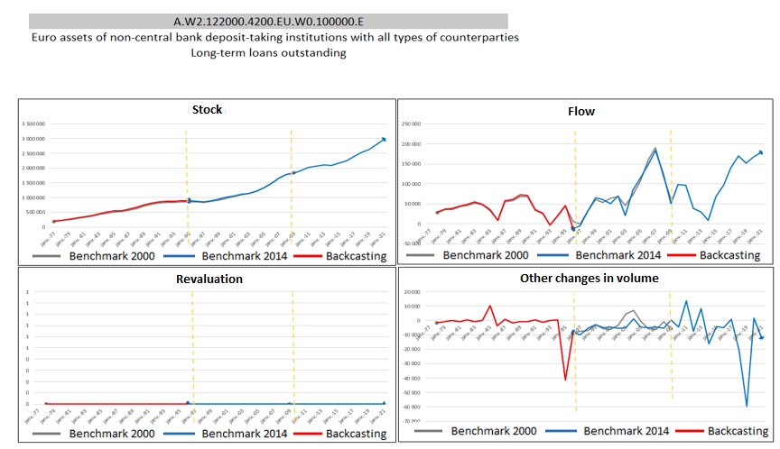
Graph 1: Example of a series with similar levels in benchmark 2000 and benchmark 2014

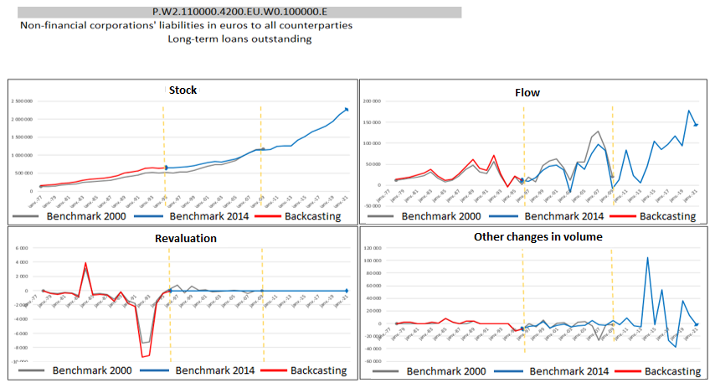
Graph 2: Example of a series whose levels are far apart in benchmark 2000 and benchmark 2014

Once this growth rate methodology has been adopted, we need to decide how to apply it at instrument level. A natural first approach is to apply this method at the finest level, instrument by instrument, and to derive the series of total assets and total liabilities for each instrument. However, such an approach leads to spontaneous divergences between total assets and total liabilities, even though this accounting equality is well respected in the series used in 2000 and 2014 benchmarks ('horizontal balancing' in the vocabulary of national accounting). This is due in particular to cross-effects between the breakdown into instruments and the application of growth rates.
The following simplified example with only 2 sectors illustrates this divergence, with total assets of 9 differing from total liabilities of 8.86.
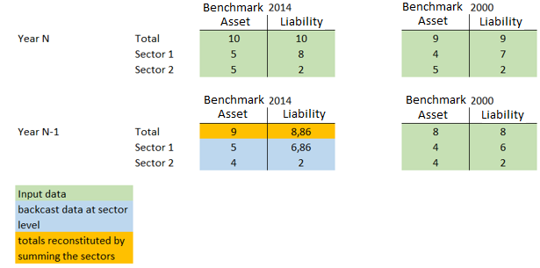
Figure 1: Illustration of the divergence between active and passive totals using a granular backcasting approach

For each financial instrument, we have therefore decided to calculate both the backward projection at the level of each sector and at the level of total assets and total liabilities (for all sectors), which will serve as our anchor.
At sector level, two cases are distinguished:
- If the new backcast series is identical to the 2000 benchmark series or very close to it, we decide to keep it as it is. In practice, we find that backcasting has little or no effect on some sectors, and we prefer to keep these series as they are rather than have accounting balancing constraints add new changes or noise to them. In practice, for a sector i, an initial estimate is calculated using the formula described above ${\hat{O}}^{i}$
$${\hat{S}}_{N-1, benchmark2014}^{i}=S_{N, benchmark2014}^{i}*\frac{S_{N-1, benchmark2000}^{i}}{S_{N, benchmark2000}^{i}}$$
And we look to see if its deviation relative to the stock for 2000 benchmark is above or below a threshold Δ in absolute value. If this is the case, we take as the final value${ S}^{i}$ the estimate ${\hat{S}}^{i}$ carried out:
$$\text{If} \left|\frac{{\hat{S}}_{N-1, benchmark2014}^{i}-S_{N-1, benchmark2000}^{i}}{S_{N-1, benchmark2000}^{i}}\right|<Δ\text{, alors }S_{N-1, benchmark2014}^{i}={\hat{S}}_{N-1, benchmark2014}^{i}$$
These series will subsequently be referred to as "fixed".

- On the other hand, if the series is further from the initial value in 2000 benchmark (or, put differently, if the relative deviation is greater than the Δ threshold we have just presented), then we will allow ourselves to modify it in order to ensure consistency between the total assets or liabilities and the sum of the instruments making up this total.
To do this, we will compare the difference between the total and the sum of the component sectors already fixed $S_{N-1}^{total}-\sum_{i fixed}{{\hat{S}}_{N-1, benchmark2014}^{i}}$ with the spontaneous sum of non-fixed sectors$\sum_{j non-fixed}{{\hat{S}}_{N-1, benchmark2014}^{j}}$. The ratio between these two values gives us a correction ratio to be applied to the non-fixed sectors to obtain the final value $S^{j}$.
$$S_{N-1, benchmark2014}^{j}={\hat{S}}_{N-1, benchmark2014}^{j}* \frac{S_{N-1,benchmark2014}^{total}-\sum_{i fixed}{{\hat{S}}_{N-1, benchmark2014}^{i}}}{\sum_{k non-fixed}{{\hat{S}}_{N-1, benchmark2014}^{k}}}$$
In the end, a correction proportional to the stocks is applied to all the non-fixed sectors. This ensures that the sum of the sectors is equal to the total calculated above. The example below extends the previous example by detailing the steps for two instruments:

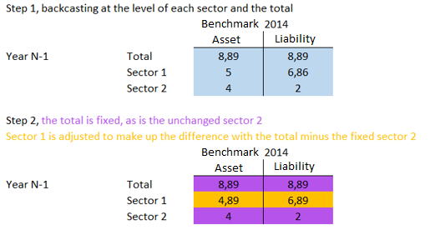
Figure 2: Illustration of the adjustment when asset and liability totals are fixed and instruments with little or no change.

In practice, we have empirically used a Δ threshold of 5% and the adjustment ratios vary widely, from 0.02% to 8%, with an average of 4.2%.

3.2. Backcasting of valuation effects

For valuation effects (noted R hereafter), it was decided to retain the ratio between valuation flows and stocks on the 2000 benchmark and to apply it on the 2014 benchmark. More precisely, we calculate the valuation flow between N-1 and N divided by the average stocks in N and N-1:
$$\frac{R_{N, benchmark 2000}}{0,5*(S_{N-1, benchmark 2000}+S_{N, benchmark 2000})}$$
This ratio is then applied to the average of stocks in N and N-1 on a 2014 benchmark.
$$R_{N, benchmark 2014}=\frac{R_{N, benchmark 2000}}{0,5*(S_{N-1, benchmark 2000}+S_{N, benchmark 2000})}∙0,5*(S_{N-1, benchmark 2014}+S_{N, benchmark 2014})$$

A strictly equivalent way of representing this is to calculate an implicit valuation index in 2000 benchmark ($I_{N, base 2000}$) and then apply it to the 2014 benchmark.
$$I_{N, base 2000}={\left[S_{N, benchmark 2000}-0,5∙\left(F_{N, benchmark 2000}+V_{N, benchmark 2000}\right)\right]}/{\left[\begin{aligned}S_{N-1, benchmark 2000}+0,5∙ \\ \left(F_{N, benchmark 2000}+V_{N, benchmark 2000}\right)\end{aligned}\right]})$$
(In this formula, which is standard in the compilation of financial accounts, we look at how the stocks in N-1 is revalued, but we also try to apply intra-period revaluation effects to the transaction flows (F) and changes in volume that occurred between N-1 and N. If we assume that the flows and changes in volume (V) are spread evenly over the period, we obtain the above formula).
In a few rare cases (494 cases out of 12 762, i.e. less than 4%), the calculation of the implicit valuation index on a 2000 benchmark may produce values that appear too high or even outliers. In particular, this may occur in the case of very small stocks and large transaction flows, revaluations and changes in volume in relation to these stocks and variation of these stocks (with potentially opposite-sign variations).
We have therefore empirically chosen a threshold on these valuation indices beyond which the 2014 valuation is calculated using an alternative method, this time calculating the proportion between revaluation flows and changes in stock on a 2000 benchmark and applying it to the 2014 benchmark:
Si $I_{N, benchmark 2000}<0.7$ ou $I_{N, benchmark 2000}>1.3$, alors
$$R_{N, benchmark 2014}=\frac{R_{N, benchmark 2000}}{(S_{N, benchmark 2000}-S_{N-1, benchmark 2000})}∙(S_{N, benchmark 2014}-S_{N-1, benchmark 2014})$$

Once these choices have been made, we can proceed in the same way for total assets and liabilities and for each sector, but we will come back to the same problem as before for stocks, i.e. having to respect equality between the revaluation of the total and the sum of the revaluations for each sector. We will proceed in the same way as for stocks, i.e.:
- For a sector i for which we have not modified the stocks (the so-called 'frozen' series), we keep the revaluation $R_{N, benchmark 2014}^{i}$ as we have calculated it. This makes it possible to have series that are free of balancing on both stocks and revaluations, and therefore to retain the natural consistency of the 2000 benchmark.
- For the others, as before, we will make the necessary adjustments to achieve the desired equality, again adjusting in proportion to the revaluations (this time using absolute values to take account of the fact that revaluations can be negative, unlike stocks):
$$R_{N-1, benchmark 2014}^{j}={\hat{R}}_{N-1, benchmark 2014}^{j}+ \frac{\left|{\hat{R}}_{N-1, benchmark 2014}^{j}\right|}{\sum_{k non_fixed}{\left|{\hat{R}}_{N-1, benchmark 2014}^{k}\right|}}\left(R_{N-1, benchmark 2014}^{total}-\sum_{i fixed }{{\hat{R}}_{N-1, benchmark 2014}^{i}}\right)$$

3.3. Backcasting of other changes in volume, deduction of flows and manual adjustments

As explained above, following several tests, we decided to finish backcasting the other volume changes and to deduce the flows from the knowledge of all the other values rather than the other way round. However, backcasting the other changes in volume is itself very difficult and raises a number of tricky questions if you want to automate it. In general, is it better to keep the other changes in volume in the 2000 benchmark as they are, assuming that they are linked to specific events that are not intended to be readjusted? Alternatively, particularly when stocks have been substantially revised, is it better to revise the other changes in volume in proportion to the changes in stocks between the two benchmarks? In principle, the answer to these questions should depend on the underlying nature of the other changes in volume (reclassification, methodological change, etc.) on a case-by-case basis. This qualitative information is documented for the most recent years;
On the other hand, the available backup of the 2000 benchmark contains the time series but not the associated metadata. In practice, it was therefore necessary to choose a systematic method while keeping a critical eye on the results obtained.
We started from an initial base of changes in volume kept unchanged, since in most cases these are reclassifications (of instruments or sectors, for example) which are more likely to remain unchanged. However, we have supplemented this choice with a few exceptions, which allow us to capture the bulk of cases where we would like to use an alternative choice. In particular, if stocks in the 2014 benchmark have become zero or have fallen very significantly, it does not seem appropriate to retain other non-zero changes in volume, and we therefore cancel them out in the new benchmark. This avoids deducing transaction flows that are more or less opposed to changes in volume for zero or very low stocks that change very little. Similarly, if, for pairs of financial instruments and sectors, stocks appear from a certain date (new source or methodological change that has not already been backcasted within the 2000 benchmark), these appearances of stocks are fully supported by the other changes in volume (a priori, as in the 2000 benchmark, but not necessarily for the same amounts because of the other methodological changes).
Finally, as with stocks and revaluations, there is a discrepancy between the sum of the sectors and the total for a financial instrument. We proceed in exactly the same way, keeping the changes in volume on the frozen series identical and adjusting the others in proportion to the other changes in volume already estimated.
Once this initial estimate of the other changes in volume has been made, the transaction flows are deduced by simple accounting equality:
$${Flow}_{q}= Stocks_{q}-Stocks_{q-1}-Revaluation_{q}-Other changes in volume_{q}$$

Once this initial work had been carried out, we manually went through the nearly 3,000 statistical series concerned to see if any other adjustments to volume were necessary. In particular, we paid close attention to :
- backcasted flows that differ too significantly or without any visible justification between the 2000 benchmark and the backcasted 2014 benchmark, and in particular peaks during concomitant changes in volume that are potentially poorly backcasted by automatic procedures;
- transaction flows and other changes in volume that are significant and in opposite directions, which could be a sign of a potential problem.

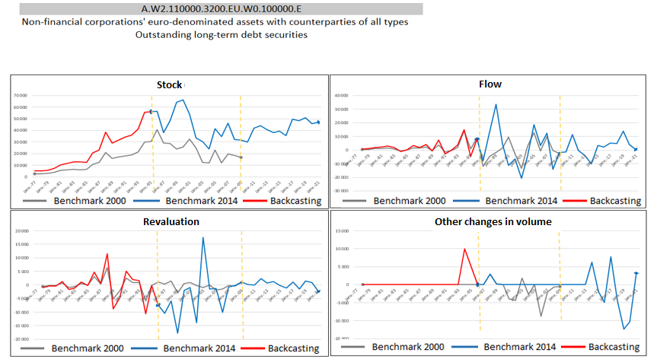
Graph 3: Example of a series whose spontaneously disproportionate flow in 1994 was adjusted using a volume change

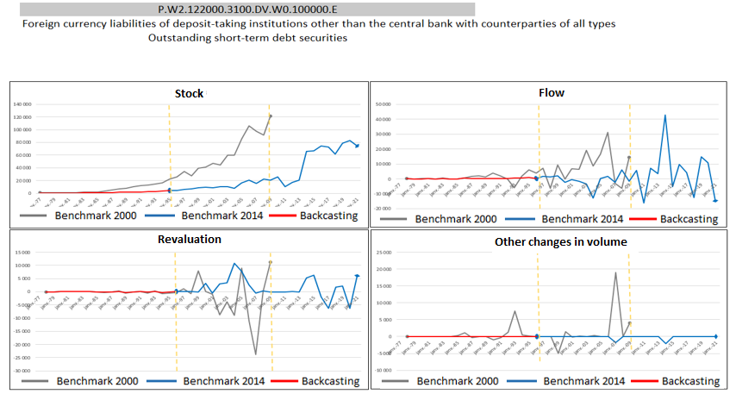
Graph 4: Example of a series in which changes in volume before 1995 have been neutralised to avoid symmetrical flows in opposite directions.

Finally, we took a closer look at the sum of transaction flows by sector, which form the net lending/borrowing of these sectors. This value, derived from the financial accounts, was already consistent in 2000 benchmark with the same value derived from the non-financial accounts produced by INSEE, either thanks to joint structural work between the Banque de France and INSEE (most often at the occasion of the national accounts benchmark), or, between two benchmarks, through adjustments to the least accurate statistical series (in practice, in the financial accounts, other accounts receivable or payable are often used for this purpose). As we wish to maintain this consistency between non-financial and financial accounts, we have paid close attention to this issue in our manual and exhaustive review to see whether a plausible adjustment to some other changes in volume might not improve the situation. We have also taken the liberty of final adjustments to ensure consistency between net lending/borrowing via other accounts receivable or payable where necessary, in line with the use that has already been made in the past of this instrument to balance the accounts.

In conclusion, the backcasting work has therefore provided us with 2,836 series between 1977 and 2021, which are both consistent with the 1995-2021 period currently covered by the current 2014 benchmark, and also with the series in the old 2000 benchmark, after the methodological adjustments necessary to ensure that the concepts correspond between the two benchmarks. The backcasted series
- respect the relationship between changes in stocks, transaction flows, revaluation flows and other changes in volume;
- also respect all the accounting equalities: assets = liabilities, sum of parts = total, etc.
- finally, they maintain consistency between the non-financial accounts and the financial accounts through the net lending/borrowing of each sector.

3.4. A special case: the consolidated debt of NFCs
The case of the consolidated debt of NFCs required special treatment. The components for its calculation are not natively present in the backcasted series, but adaptations have been made so that this series is still available, given its importance for economic analysis and monitoring.
The consolidated debt of French NFCs, presented in various publications such as the Stat Info "Debt ratio of non-financial agents - International comparisons", is calculated as the sum of:
- of financial sector loans granted to NFCs. Loans granted by other NFCs are therefore excluded (intra-sector consolidation).;
- debt securities in the liabilities of NFCs at nominal value.

For more details on the different consolidation options, please refer to the methodological note accompanying Stat Info.
The distinction between financial sector loans to NFCs and other types of loans on the liabilities side of NFCs already existed in the 2000 benchmark. The same backcasting techniques have therefore been used, taking the series of total loans to NFCs as already determined (because it has already been retropolated). We then look at how to backcast the breakdown into the two components. In practice, the series of financial sector loans to NFCs turn out to be very similar in benchmark 2000 and benchmark 2014, and it is the rest of the loans to NFCs that bear the differences observed between the two benchmarks, as illustrated by the graphs below. In concrete terms, the revisions seem to stem mainly from the source data used on companies and in particular on intra-resident NFC loans and, to a lesser extent, from revisions to Balance of Payments data for loans granted by non-resident companies outside the financial sector).

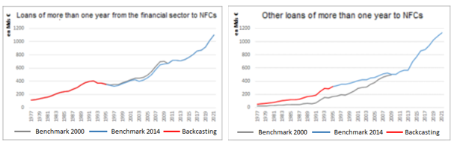

For debt securities at nominal value (NV), the securities statistics have series going back to 1989. To go back further, we used the series of stocks (S) and revaluations (R) of securities at market value (MV) to recalculate the series at par value:
$$S_{N-1}^{NV}=S_{N}^{NV}-\left(S_{N}^{MV}-S_{N-1}^{MV}-R_{N}^{MV}\right)$$
If we apply this method to periods when we already have the nominal value, we observe correct results, even if they are not completely identical. The approximation is therefore largely satisfactory, especially as the proportion of bonds in NFC debt was much lower in the 1980s (and we are only talking about approximating as closely as possible the difference between market value and nominal value, which are already relatively close).

4. Quarterly reporting

So far, we have worked with annual data, which has simplified the problems to some extent. However, as many of the statistical series of the national financial accounts are disseminated via quarterly series (dissemination on the Banque de France statistical portal, sharing with international organisations such as the ECB or the OECD, etc.), we felt it would be useful to also produce and disseminate backdata series at quarterly level.
To do this, we used similar principles to those we have seen previously and, in particular, we applied the quarterly profile observed in benchmark 2000 to the benchmark 2014. However, we differed in the nature of the instruments backcasted: whereas we had previously backcasted the series of stocks, valuations and other changes in volume in order to reconcile with transaction flows, for the quarterly adjustment we worked on transaction flows, valuations and other changes in volume in order to finally reconcile with stocks. In fact, for these first three types, in addition to the horizontal balancing constraints (equality between liabilities and assets) and the aggregation constraints (the sum of the series at the finest level must give the aggregated series which form the total), there is the constraint that the sum of the quarterly values must give the annual value. For stocks, this constraint is absent.
In the absence of a relevant infra-annual indicator, some simplifications had been made for the quarterly backcasting to the benchmark 2000. These series were therefore estimated. The sectors and instruments concerned and the technique used to estimate these series in benchmark 2000 are detailed in the appendix.
The other changes in volume from the benchmark 2000 were conventionally positioned in the 4th quarter in the absence of more precise information. For the same reason, the same principle has been adopted for the 2014 benchmark.
The process is the same for transaction and valuation flows, so we will present the approach for flows.
If we take the distribution of the 2000 benchmark of flows between the quarters Q_{p} of year N, we start with the following first formula:
$${\hat{F}}_{Q_{p},N, benchmark 2014}^{i}=F_{N, benchmark 2014}^{i}*\frac{{\hat{F}}_{Q_{p},N, benchmark 2000}^{i}}{F_{N, benchmark 2000}^{i}}$$
This consists of applying the ratio between the flow of a quarter Q_{p} ${\hat{F}}_{Q_{p},N, base 2000}^{i}$ in benchmark 2000 with the annual flow${ F}_{N, base 2000}^{i}$, again in benchmark 2000 and then applying this ratio to the annual flow in backdated benchmark 2014.
There are two exceptions to this general approach:
- if the annual flow in benchmark 2000 is zero
- or if the annual flow in benchmark 2000 and benchmark 2014 are of opposite sign
for a year N, then the simplification applied is that the quarterly flows of the backcast benchmark is equal to a quarter of the annual flow for that year.
Once these choices have been made, we can proceed in the same way for total assets and liabilities and for each sector, but we will come up against the same problem as before for annual backcasting: we will have to respect the equality between flows on totals and the sum of flows for each sector (which unfortunately is not naturally achieved). We will proceed in a similar way:
For a sector i for which we have made little or no change to the annual flows, i.e.
$$\text{if }\left|\frac{F_{N, benchmark 2000}^{i}-F_{N, benchmark 2014}^{i}}{F_{N, benchmark 2000}^{i}}\right|<Δ$$
then we keep the quarterly flows previously estimated :
$F_{Q_{p},N, benchmark 2014}^{i}={\hat{F}}_{Q_{p},N, benchmark 2014}^{i}$.
In practice, we have taken a Δ threshold of 5%.

- For the other sectors, as before, we will make the adjustments necessary to achieve the desired equality on the total, by reallocating to the unfrozen series the difference between the total and the sum of the parts $\left(F_{Q_{p},N, benchmark 2014}^{total}-\sum_{i }{F_{Q_{p},N, benchmark 2014}^{i}}\right)$ for each quarter Tp and weighting by the weight of flows between non_fixed series $\frac{\left|F_{N, benchmark 2014}^{j}\right|}{\sum_{k non figés}{\left|F_{N, benchmark 2014}^{k}\right|}}$ (taking absolute values to account for the fact that flows can be negative) :
$$F_{Q_{p},N, benchmark 2014}^{j}={\hat{F}}_{Q_{p},N, benchmark 2014}^{j}+ \frac{\left|F_{N, benchmark 2014}^{j}\right|}{\sum_{k non figés}{\left|F_{N, benchmark 2014}^{k}\right|}}\left({\hat{F}}_{Q_{p},N, benchmark 2014}^{total}-\sum_{i }{{\hat{F}}_{Q_{p},N, benchmark 2014}^{i}}\right)$$
For the breakdown between non-fixed series, it should be noted that we have chosen weights based on annual series and not quarterly series, in order to apply the same weight to each quarter and thus not break the equality between annual and quarterly flows, bearing in mind that we naturally have
$$\sum_{the 4 quarters p}{\left({\hat{F}}_{Q_{p},N, benchmark 2014}^{total}-\sum_{i }{{\hat{F}}_{Q_{p},N, benchmark 2014}^{i}}\right)=0}$$
Finally, a manual review of the conversion to quarterswas also carried out to ensure the consistency of the choices made.

Appendix 1: details of methodological jointing work

- The financial instruments joint between ESA 1995 and ESA 2010
  - Breakdown of F.333 into F.32

Long-term interbank market securities (F.333) cover transactions in long-term interbank market securities. They include negotiable promissory bills, mortgage bills and bank certificates with compound agios (interest payable in advance) or post-counted agios (interest payable at maturity). In benchmark 2000, they appeared in an accounting line F.333 separate from long-term debt securities (F.332); only instrument F.332 was available with a breakdown in Euro (EU) and foreign currencies (DV).

In 2014, long-term interbank market securities (F.333) are reintegrated into long-term debt securities (F.32) according to the breakdown in Euro (EU) and foreign currencies (DV). In view of the low relative weight of F.333 compared with F.32, it was decided to assume a similar EU/DV breakdown between F.333 and F.32, and therefore to calculate a breakdown coefficient for F.32 over the period 1977/1994 on a 2000 benchmark for each sector (non-resident, credit institutions, other financial intermediaries), on the assets and liabilities sides, and to apply this coefficient to F.333 all currencies (TT) over the period 1977/1994. This method also gives good results for the period 1995-2009.

  - Breakdown of F.380 into F.31

Accrued interest not yet due on negotiable debt securities (F.38) represents interest already generated by a negotiable debt security but not yet paid.
In benchmark 2000, while accrued interest not yet due on bonds is already included in its holder (F.332), accrued interest not yet due on negotiable debt securities is recorded in an accounting line (F.380) separate from F.331.

Instrument F.38 (benchmark 2000) is reintegrated into short-term debt securities (F.31) and, here again, a breakdown must be made between euros and foreign currencies. The same type of breakdown coefficient is applied (calculation of the breakdown of F.31 EU/DV over 1977/1994 on the benchmark 2000 and application of the coefficients to F.380 TT over the period 1977/1994), this time with the added justification that the breakdown of accrued interest not yet due is roughly proportional to that of stocks (with the limitation that the level of interest rates may nevertheless differ between currencies).

  - Breakdown of F.512 (SEC 1995) into F.512 and F519 (SEC 2010)

Unlisted shares (F.512) were grouped with other holdings (F.513) in F.512 in the 2000 benchmark.

To provide this distinction between unlisted shares (F.152) and other holdings (F.519) present in benchmark 2014 but absent from benchmark 2000, we have calculated, for each sector, the average distribution observed in benchmark 2014 between 1995 and 2009 and applied this distribution to the period 1977-1994.

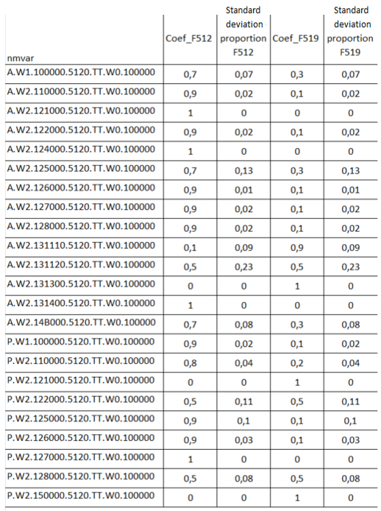
In the vast majority of cases, the volatility of the split between F.512 and F.519 is relatively contained. Moreover, cases with higher volatilities generally concern sectors with low stocks, which makes the approximation acceptable.

  - Adding F.523 to F.522

In benchmark 2000, subheading F.523 covers transactions in shares of various investment funds, including units in venture capital mutual funds (FCPR), company mutual funds (FCPE), futures market mutual funds, real estate investment trusts (SCPI) and foreign mutual funds.

This F.523 instrument is fully included in non-money-market mutual fund units (F.522), and no additional methodological problems are to be noted.

  - Breakdown of F.611 into F.621 and F.622

The breakdown provided for in ESA 1995 between net equity of households in life insurance technical reserves (F.611) and net equity of households in pension funds (F.612) was not applied in the 2000 benchmark. Both were grouped together in accounting item F.611.

To provide this distinction, which is present in benchmark 2014 but absent from benchmark 2000, we have calculated the average breakdown observed in benchmark 2014 between 1995 and 2009 and applied this breakdown to the period 1997-1994. However, this methodological choice remains very fragile, given that a fixed coefficient had already been used to estimate these series before 2009, (and we assume that there were far fewer pensions in the 80s and 90s). The construction of these series will be the subject of a specific study and will be reviewed at a later date.

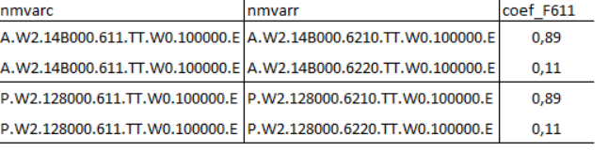

  - Processing standard warranties (F.66)

As the amounts in F.66 are very low, or even zero, in benchmark 2014, this series has not been backcasted.

- Joining institutional sectors between ESA 1995 and ESA 2010

Estimation of series in S.127

Series on captive financial institutions and non-institutional lenders (sector S.127) are not available in benchmark 2000 for the years 1977-1994.
Only 13 series, non-zero in benchmark 2014, can be backcasted:

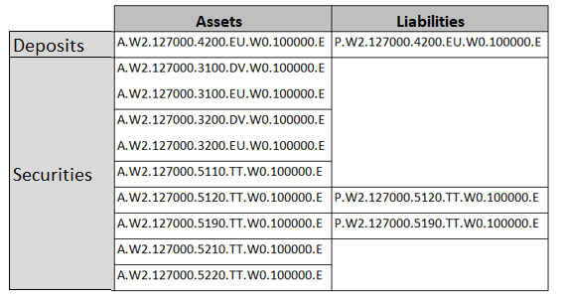

To estimate them over this period, we have opted for a simple estimation method.

In the absence of accounting information, the assumption made is identical to that used for the transition from the 2000 benchmark to the 2005 benchmark. An initial estimate of the S.127 series is made using the S.126 series for the period 1995/2001, with which there is a strong correlation. An estimation coefficient for S.127 is then deduced on the average of this period. The table below shows the correlation coefficients and estimation coefficients used:

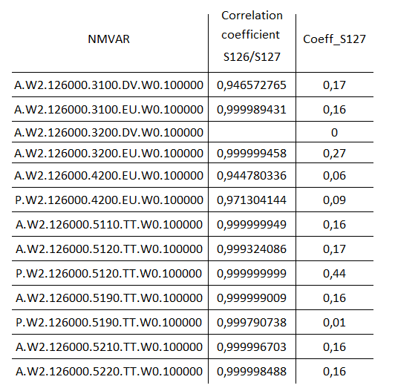

Secondly, we assume that the amount of the S.127 series was included in the respective S.126 and S.11 series. We have therefore chosen to remove 92% of the estimated S.127 amount from S.126, and to proceed in the same way with S.11, to the extent of 8%.
To respect the proportions of S127 to S.126 shown in the table above, we have the following relationship
$${\hat{S127}}_{N,retropolated benchmark }^{i}={Coeff_{S127}}_{N, benchmark 2014}^{i}*{\hat{S126}}_{N, benchmark basis}^{i} \\ ={Coeff_{S127}}_{N, benchmark 2014}^{i}*\left({S126}_{N, benchmark 2000}^{i}-0.92*{\hat{S127}}_{N, retropolated benchmark }^{i}\right)$$

and we derive the following formula for estimating the S.127 series:
$${\hat{S127}}_{N, retropolated benchmark }^{i}={S126}_{N, benchmark 2000}^{i}*\frac{{Coeff_S127}_{N, benchmark 2014}^{i}}{{Coeff_S127}_{N, benchmark 2014}^{i}*0.92+1}$$

Following this estimate, the following formulae are applied to the S.126 and S.11 series to remove the respective share of S.127
${\hat{S126}}_{N, retropolated benchmark }^{i}={S126}_{N, benchmark 2000}^{i}-0.92$*${\hat{S127}}_{N, retropolated benchmark }^{i}$

$${\hat{S11}}_{N, retropolated benchmark }^{i}={S11}_{N, benchmark 2000}^{i}-0.08*{\hat{S127}}_{N, retropolated benchmark }^{i}$$

- Other special cases
  - Modifying a series
The series P.W2.131110.2960.EU.W0.100000 (correspondent accounts) in benchmark 1995 has been changed to P.W2.131110.2100.EU.W0.100000 (coins and banknotes) in benchmark 2014.

  - Series reflection
The series below are not available in the 2000 benchmark for the years 1977-1994.

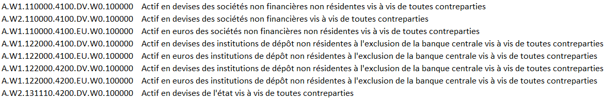

In the illustration below, we seek to estimate the margin series A.W1.110000.4100.DV.W0.100000 (Foreign currency assets of non-resident non-financial corporations vis-à-vis all counterparties) in benchmark 2000.
In 2014 benchmark, we note that this margin series consists solely of the following "who to whom" (w-t-w) series A.W1.110000.4100.DV.W2.110000 (Foreign currency assets of non-resident non-financial corporations vis-à-vis resident non-financial corporations). At this stage, there is nothing to allow us to estimate the margin series properly. To this end, we have observed the behavior of the series in reflected w-t-w: P.W2.110000.4100.DV.W1.110000- (Foreign currency liabilities of resident non-financial corporations vis-a-vis non-resident non-financial corporations), which is a component of the series in margin: P.W2.110000.4100.DV.W1.100000 (Foreign currency liabilities of resident non-financial corporations vis-a-vis the rest of the world).
For the latter series, amounts in benchmark 2000 and 2014 are available, and for the series in reflected w-t-w, an amount in benchmark 2014. An estimate of the series in reflected w-t-wis then made in benchmark 2000 according to the formula below.

$$S_{N-1 wtw, benchmark 2000}=S_{N wtw, benchmark 2014}*\frac{S_{N-1 Margin, benchmark 2000}}{S_{N Margin, benchmark 2014}}$$

The estimated amount of the reflected w-t-w series is then carried over to the initial w-t-wseries, and the margin series can then be deducted.
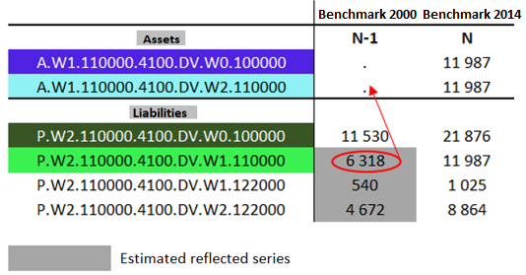

4. Estimation of some quarterly series in benchmark 2000 before estimation of the same series in benchmark 2014
For the quarterly backcast to benchmark 2000, in the absence of sufficiently granular quarterly series, quarterly retropolations were carried out at a slightly more aggregated level, followed by disaggregation to recover the more detailled series. These simplifications concern:
- the household sector (S14) was backcasted globally, without distinguishing between sole proprietors (S.14A) and individuals (S.14B),

- mutual funds were backcasted globally, without taking into account the distinction between money-market funds (S.122F) and non-money-market funds (S.123B)

- the following financial transaction headings have not been broken down between euros and foreign currencies (F.291, F.292, F.422, F.332)

- quoted and unquoted shares in foreign companies (F.5112 and F.5122) have been summed.

- further aggregations have been made between loans between non-financial agents and short-term trade credits (F.419 and F.711), long-term trade credits (F.429 and F.712), transferable deposits and bills and coins in euros (F.2101 and F.2201) and in foreign currencies (F.2102 and F.2202), and mutual fund shares and units (F.521, F.522 and F.523).

- finally, for the lines on long-term debt securities (F.332) and shares and mutual fund shares (F.5), the ODAC, APUL and ASSO sectors were not distinguished.

For the series listed above, the following formula is applied to each quarter Tp of year N to estimate the disaggregated series:${\hat{F}}_{T_{p},N, benchmark 2000}^{i}=F_{N, benchmark 2000}^{i}*\frac{F_{T_{p},N, benchmark 2000}^{i}}{\sum{the 4 quarters(F_{T_{p},N, benchmark 2000}^{i})}}$

Exemple :

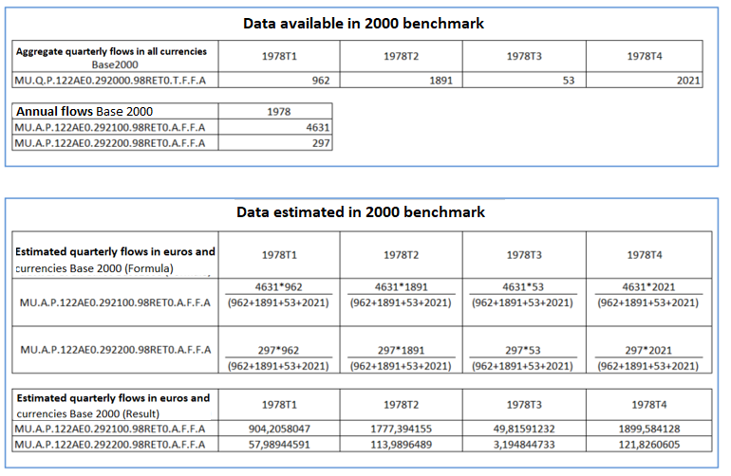

Webstat - Le portail statistique de la Banque de France (banque-france.fr) or directly in the download area
National financial accounts - Time series | Banque de France (banque-france.fr)
Debt ratios by institutional sectors - international comparisons | Banque de France (banque-france.fr)
Stat Info (banque-france.fr),
Webstat - Le portail statistique de la Banque de France (banque-france.fr) or directly in the download area

